Subnet
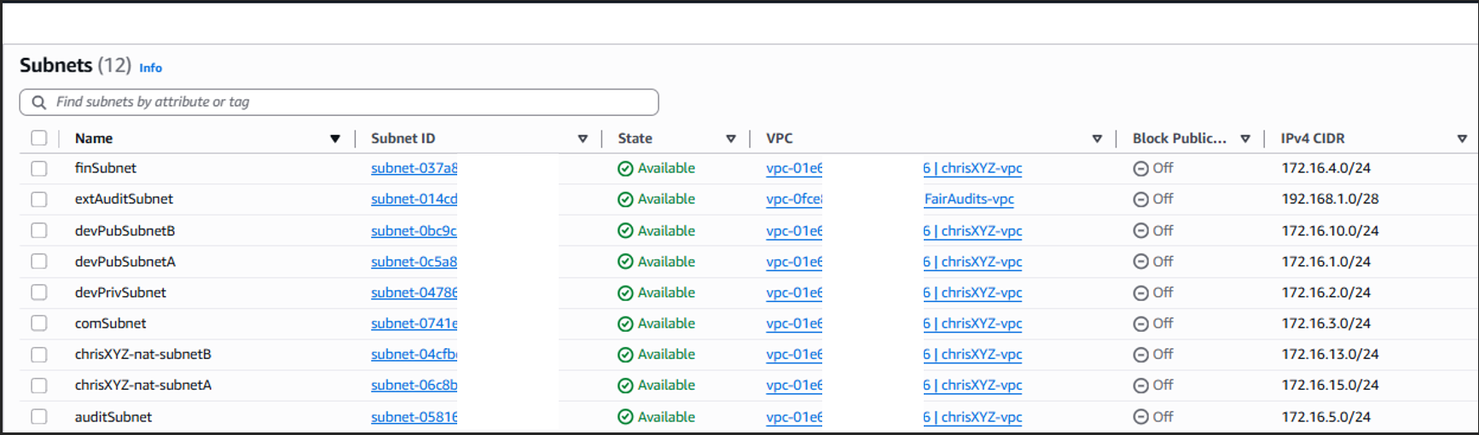

Route Table
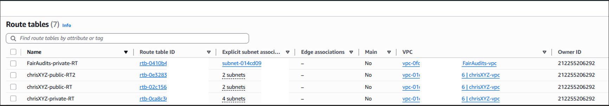

ChrisXYZ Route Tables
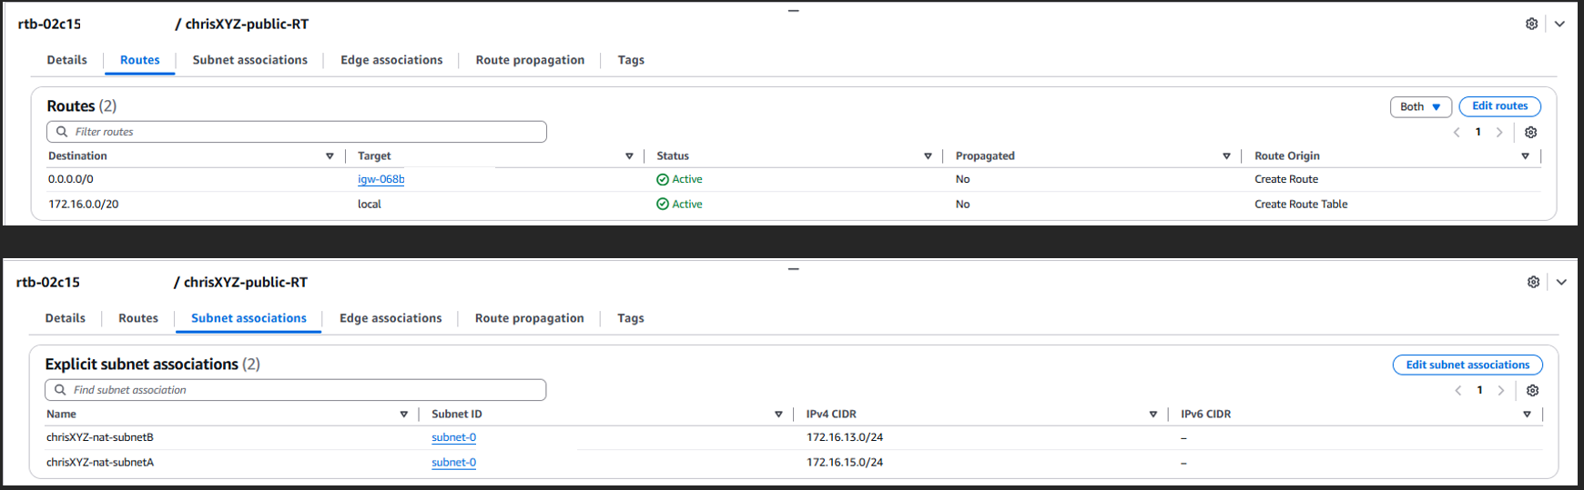
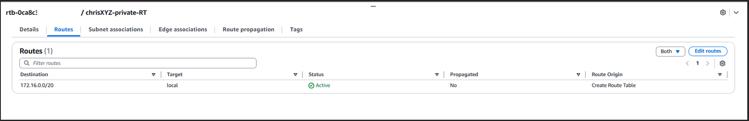
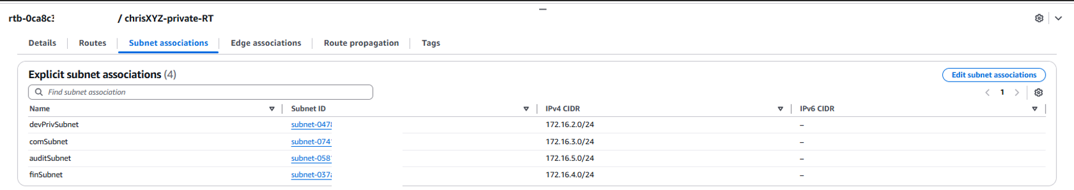
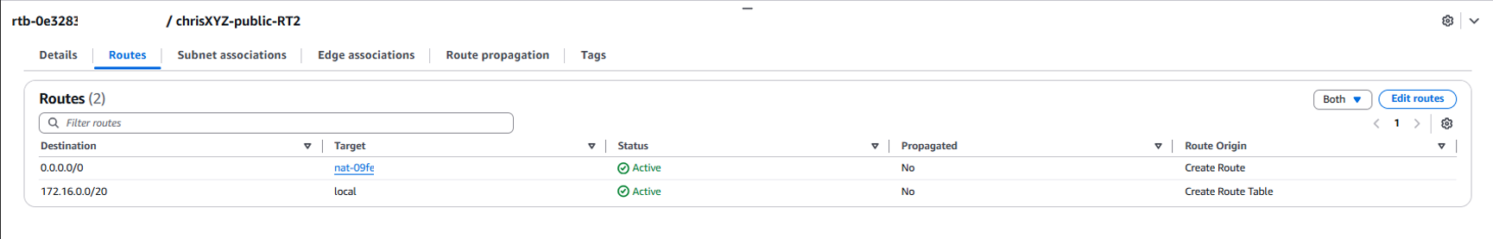
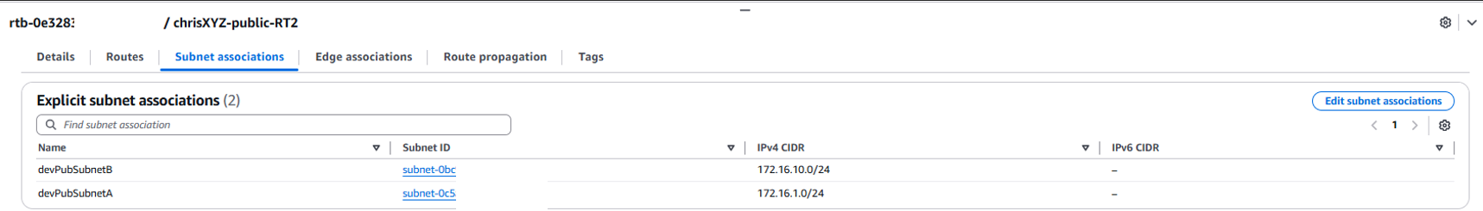
FairAudits Route Table
